Project Documentation

**FITFLEX –PERSONAL FITNESS COMPANION**

# Introduction

## Project Title: FITFLEX –PERSONAL FITNESS COMPANION

* + **Team ID** 4C34F5B0273AF98A98F443F7ECD11D98
  + **Team Leader:** SAMIKSHA G [samikshagandhi0111@gmail.com](mailto:samikshagandhi0111@gmail.com)

## Team Members:

* + - SAFRIN FATHIMA A [safrinmubina@gmail.com](mailto:safrinmubina@gmail.com)
    - SAFIHA S [safihas955@gmail.com](mailto:safihas955@gmail.com)
    - THAMIZHRASI R [thamizharasiramaingam7@gmail.com](mailto:thamizharasiramaingam7@gmail.com)

# Project Overview

* + **Purpose:** SB Works connects clients and freelancers through project postings, bidding, and real-time communication.

## Features:

* + - Project posting and bidding
    - Secure chat system
    - Feedback and review system
    - Admin control panel

# Architecture

* + **Frontend:** React.js with Bootstrap and Material UI
  + **Backend:** Node.js and Express.js managing server logic and API endpoints
  + **Database:** MongoDB stores user data, project information, applications, and chat messages

# Setup Instructions

## Prerequisites:

* + - Node.js
    - Git
    - React.js
    - Express.js **–** Mongoose **–** Visual Studio Code

## Installation Steps:

# Clone the repository git clone

# Install client dependencies cd client npm install

# Install server dependencies cd

../server npm install

# Folder Structure

SB-Works/

|-- client/ # React frontend

| components/ L pages/

| server/ # Node.js backend

| routes/

| models/

| controllers/

# Running the Application

## Frontend:

cd client npm start • **Backend:**

cd server npm start

* + **Access:** Visit [http://localhost:3000](http://localhost:3000/)

# API Documentation

## User:

* + - /api/user/register
    - /api/user/login

## Projects:

* + **Chats:**
* /api/projects/create
* /api/projects/:id • **Applications:** /api/apply
* /api/chat/send
* /api/chat/:userId

# Authentication

* + JWT-based authentication for secure login
  + Middleware protects private routes

# User Interface

* + Landing Page
  + Freelancer Dashboard
  + Admin Panel
  + Project Details Page

# Testing

* + Manual testing during milestones
  + Tools: Postman, Chrome Dev Tools

1. **Screenshots or Demo**

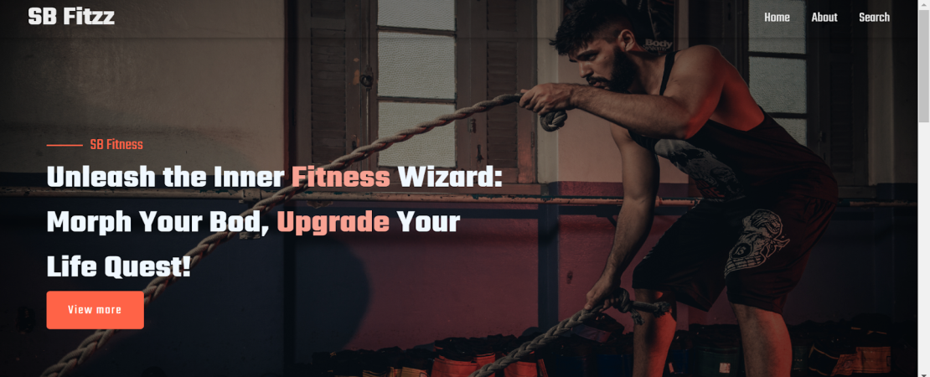

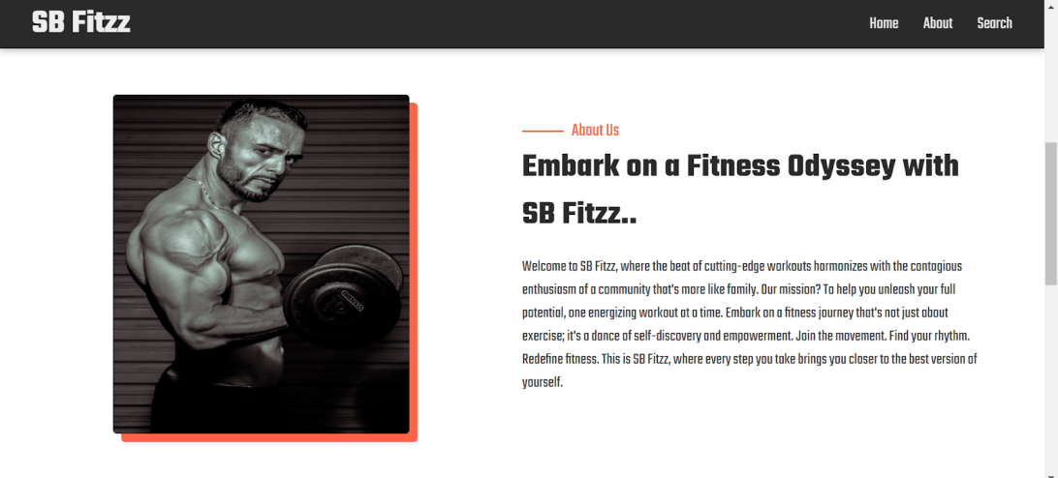

1. **Known Issues**

* Requires continuous internet connection (no offline mode).
* Relies on third-party fitness APIs (may cause downtime/inconsistencies).
* Limited personalization of workout routines.
* Possible performance issues on low-end devices due to heavy media content.
* Accessibility features are not fully implemented for all users.

1. **Future Enhancements**

* Add AI-based personalized workout and diet plans.
* Introduce offline mode with downloadable content.
* Integrate with wearables (smartwatches, fitness trackers).
* Add community features (challenges, leaderboards, social sharing).
* Provide voice assistant support for hands-free workout guidance.
* Support multiple languages and regional content.
* Advanced analytics and progress tracking dashboards.